Eur-Greece-Arcadia, Tegea-Hygeia-350—325 BCE

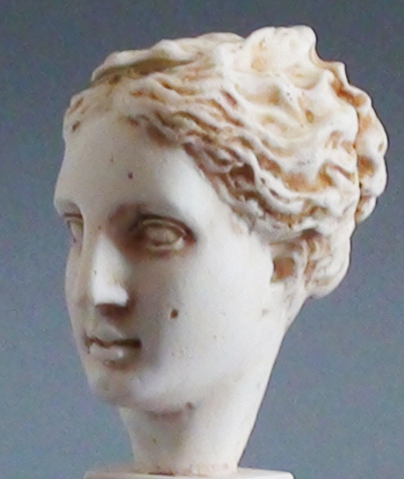

|  |  |
| --- | --- |
| |  | | --- | |  | |

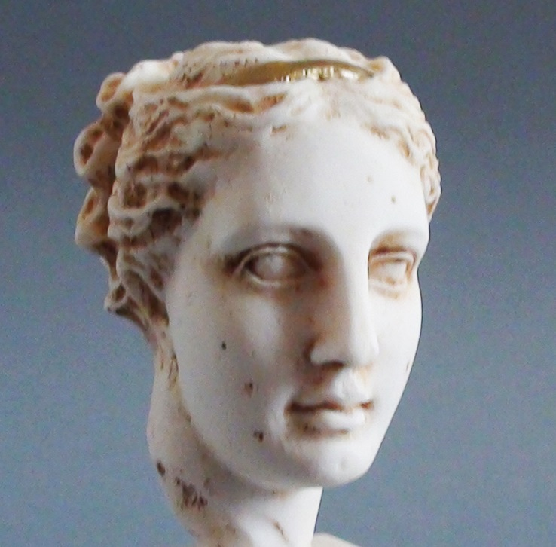 [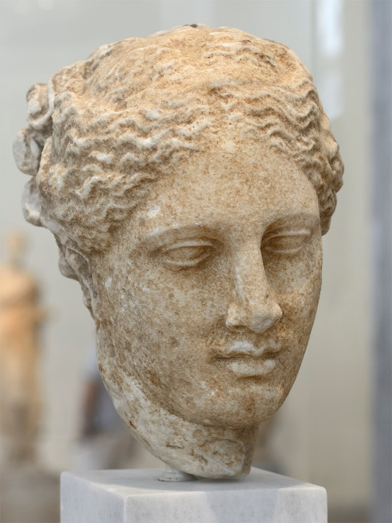](http://ancientrome.ru/art/artwork/sculp/mythology/gr/hygieia/hyg005.jpg)

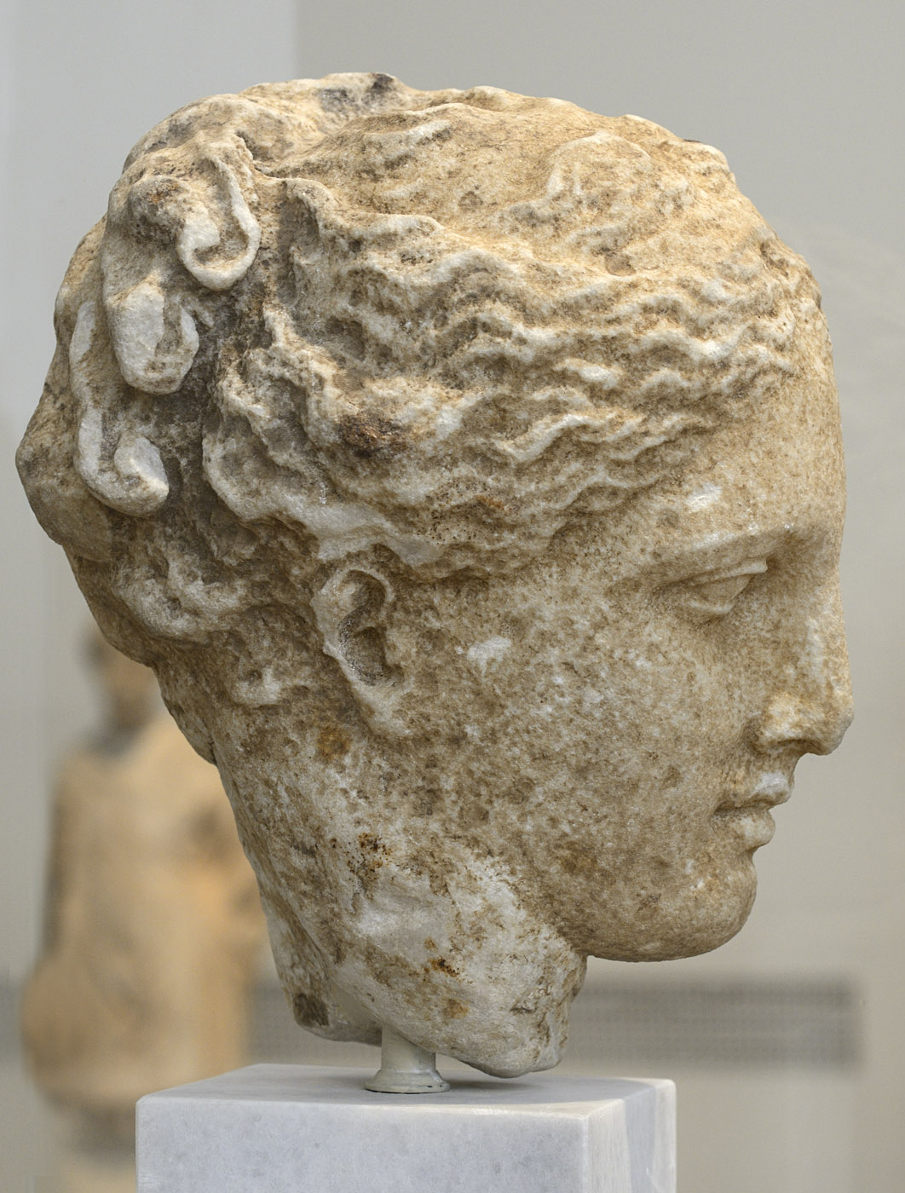

Female head (Hygieia?).

Marble. Greek work, 350—325 BCE.  
Inv. No. 3602.

Athens, National Archaeological Museum  
(Αθήνα, Εθνικό Αρχαιολογικό Μουσείο)

Found at Tegea, Arkadia.

Marble female head, probably Yγιείας, from Tεγέα Aρκαδίας (Tegea, Arkadia)

350-325 BCE

The head of the young woman, with the wavy hair pulled back, exudes divine beauty and grace. The view that it belongs to the statue of Yigias, which was sculptor Skopas, has been disputed. However, it is one of the finest original works of the late classical period.

Height 0.285m.